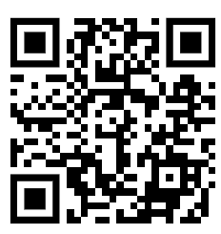

**M11: AMERICAN DREAM © WILL.I.AM, 2021**

<https://www.youtube.com/watch?v=1NjH_pVai2M>

Get inspired by this song and write down as many associations as you can think of.

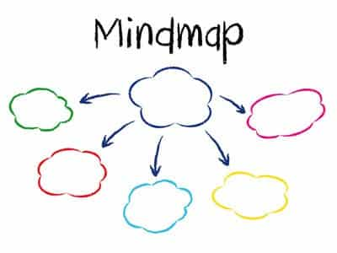

© Gooseman - Fotolia.com