

**M5: AMERICAN OXYGEN[1] © RIHANNA, 2015**

<https://www.youtube.com/watch?v=Ao8cGLIMtvg>

1. **Getting started: Note down your associations with the title of the song.**
2. **Listen to the song and have a look at the lyrics:**
3. **Choose words that describe how the song makes you feel (and be prepared to explain why.)**

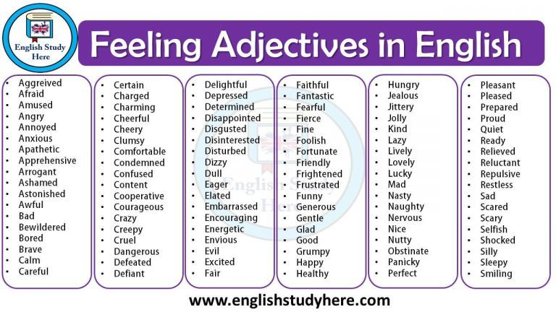

<https://i.pinimg.com/originals/ce/bc/99/cebc99d2bdc5ff361c74cbd2da643f40.jpg> (last accessed: March 19, 2023)

1. **Have a look at the text and try to summarize the main message of the song.**

Breathe out, breathe in  
American oxygen  
Every breath I breathe2  
Chasin' this American Dream  
We sweat for a nickel and a dime3  
Turn it into an empire  
Breathe in, this feeling  
American, American oxygen

American oxygen  
Breathe in, this feeling  
American, American Oxygen

Oh say can you see4, this is the American Dream  
Young girl, hustlin'5  
On the other side of the ocean  
You can be anything at all  
In America, America  
I say, can't you see  
Just close your eyes and breathe

Auf dieser Seite wird Software / werden Dienste / Videos vorgestellt, bei denen Daten auf externen Servern verarbeitet werden können. Die Nutzung ist für Sie freiwillig. Bei der Verwendung von Daten Dritter sind die rechtlichen Rahmenbedingungen zu beachten.

Breathe out, breathe in  
American oxygen  
Every breath I breathe  
Chasin' this American Dream  
We sweat for a nickel and a dime  
Turn it into an empire  
Breathe in, this feeling  
American, American oxygen

American oxygen  
Breathe in, this feeling  
American, American Oxygen

American oxygen  
Breathe in, this feeling  
American, American Oxygen

Oh say can you see, this is the American Dream  
Young boy, hustlin'  
Tryna6 get the wheels in motion  
But he can be anything at all  
In America, America  
I say, can't you see  
Just close your eyes and breathe

**(3) Now watch the video :**

1. **Use a second color and mark the words in (2a) which you would choose now.**
2. **Try to identify some of the scenes presented in the video and complete the mind map below.**

**USA**

**(4) Good angel or bad angel? Take your notes as a starting point and discuss this question.**

1. oxygen = O2(Sauerstoff); 2 to breathe = atmen, breath = Atem; 3 nickel = 5 cents, dime = 10 cents

   4 Oh say can you see” = first line of the US national anthem (Hymne) 5 to hustle: double meaning = to hurry / to be a prostitute

   6 tryna = trying to

   .