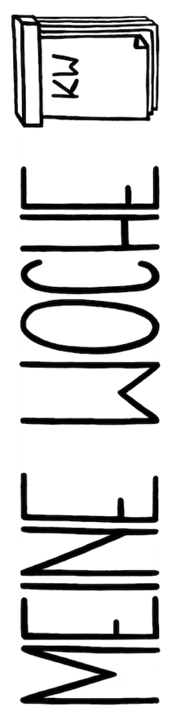
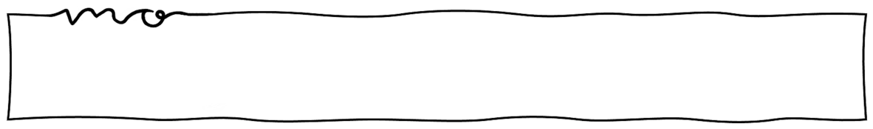


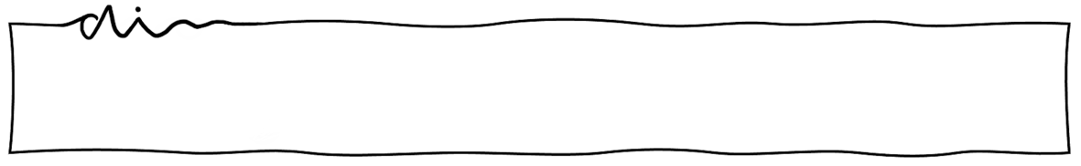
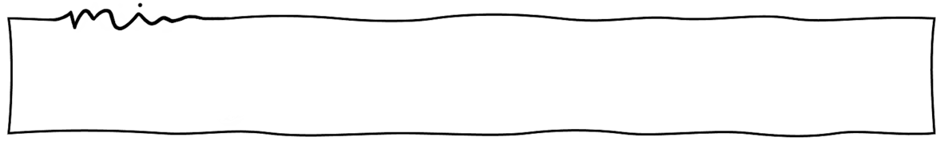
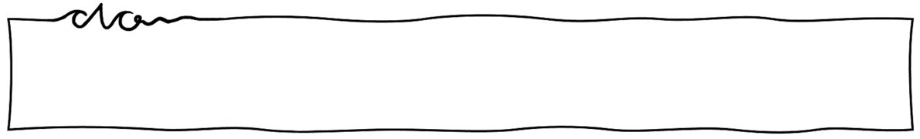
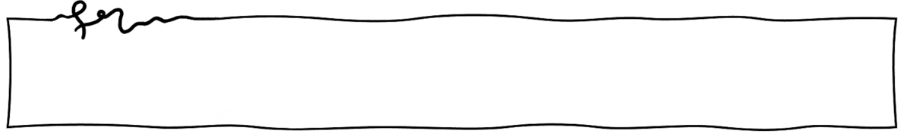
E V E N I N G
C H E C K O U T
M O R N I N G
C H E C K I N
I C H B I N
D A N K B A R F Ü R
I C H F Ü H L E
M I C H
I C H F Ü H L E
M I C H
I C H B I N
D A N K B A R F Ü R
I C H B I N
D A N K B A R F Ü R
I C H F Ü H L E
M I C H
I C H B I N
D A N K B A R F Ü R
I C H F Ü H L E
M I C H
I C H B I N
D A N K B A R F Ü R
I C H F Ü H L E
M I C H

